**TCP/IP Attacks**

**Karan Amrutesh**

**Task 1: SYN Flooding Attack:**

* **Server:** We initially check the status of the queue i.e., the number of half open connections associated with the listening port using the netstat command:

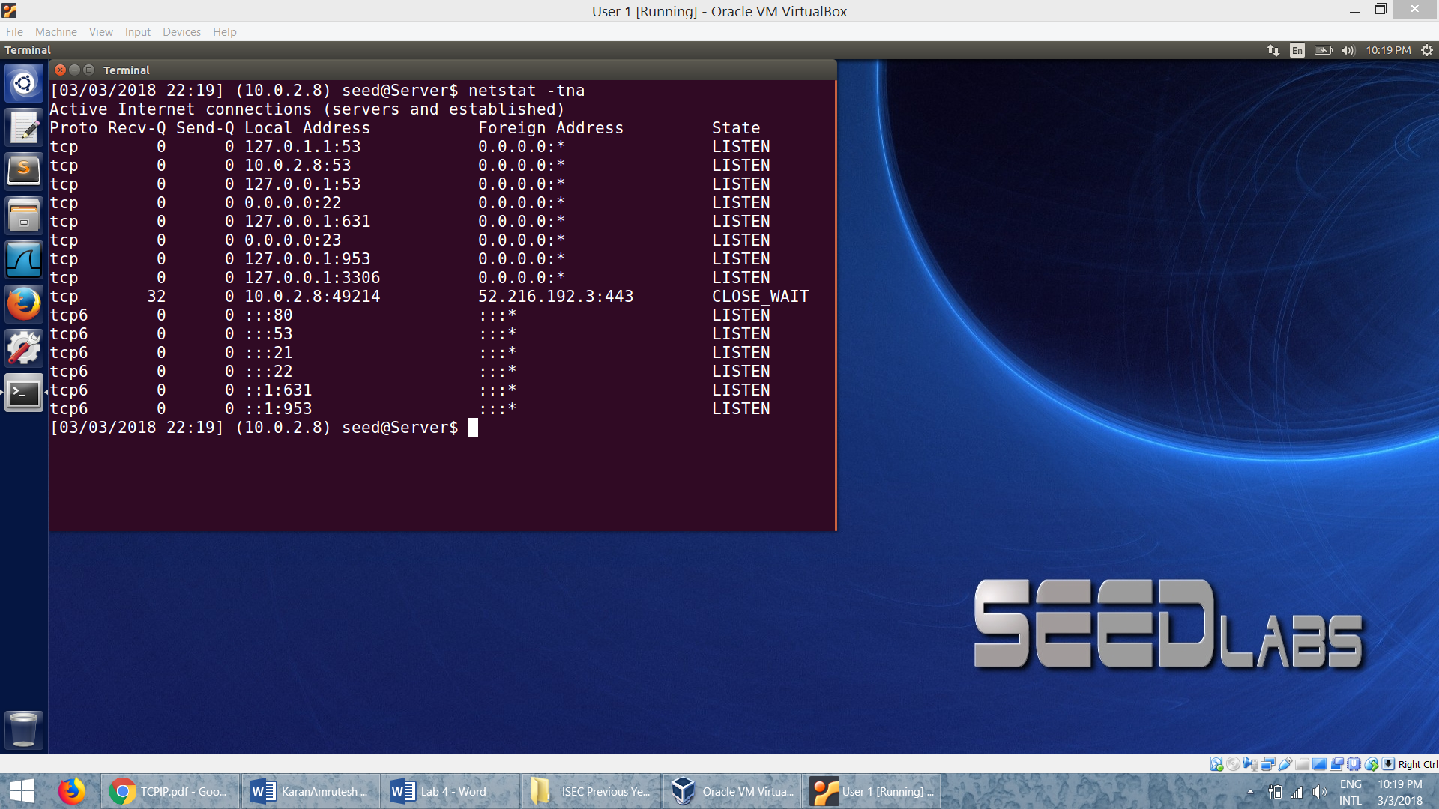

* **Attacker**: We use the netwox tool with number 76 to carry out the syn attack. We also specify the destination IP address (10.0.2.8) and destination port number (23):

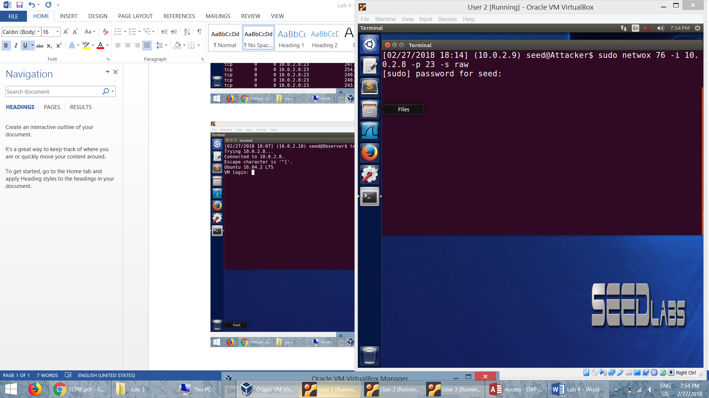

* **Server**: The status of the queue when we receive the SYN packets from the attackker:

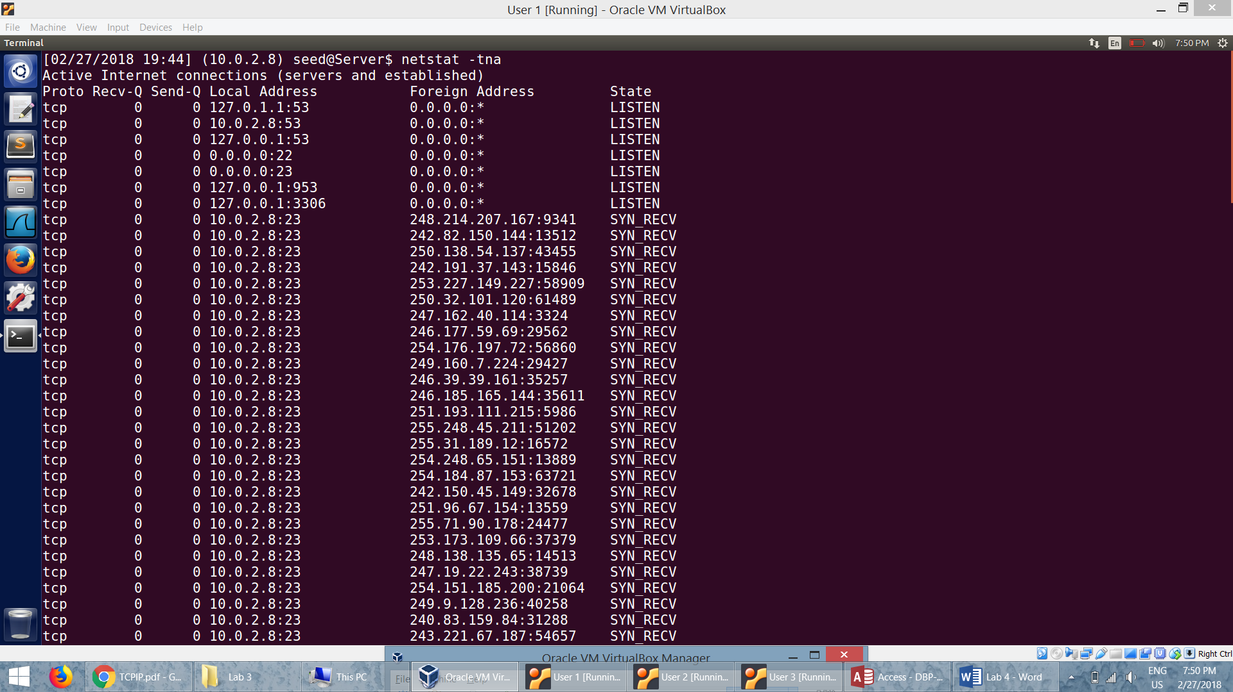

**Task 2: Attack on telnet connection:**

* **Attacker**: We use the netwox tool with number 76 to carry out the syn attack. We also specify the destination IP address of the server (*10.0.2.8*) and destination port number (23):



* Before the syn cookie mechanism is turned off we can see that the telnet from the Observer *(10.0.2.10)* to the server *(10.0.2.8) works:*

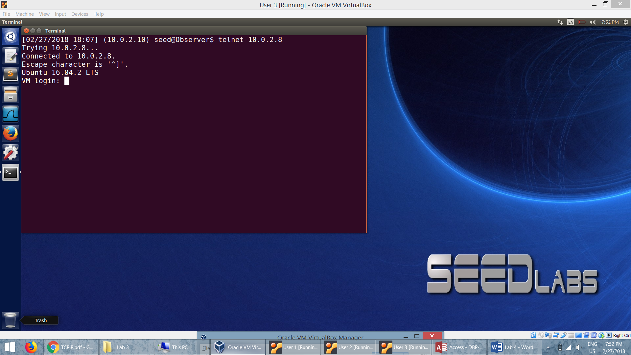

* The wireshark capture at the Server when we receive a lot of SYN packets:

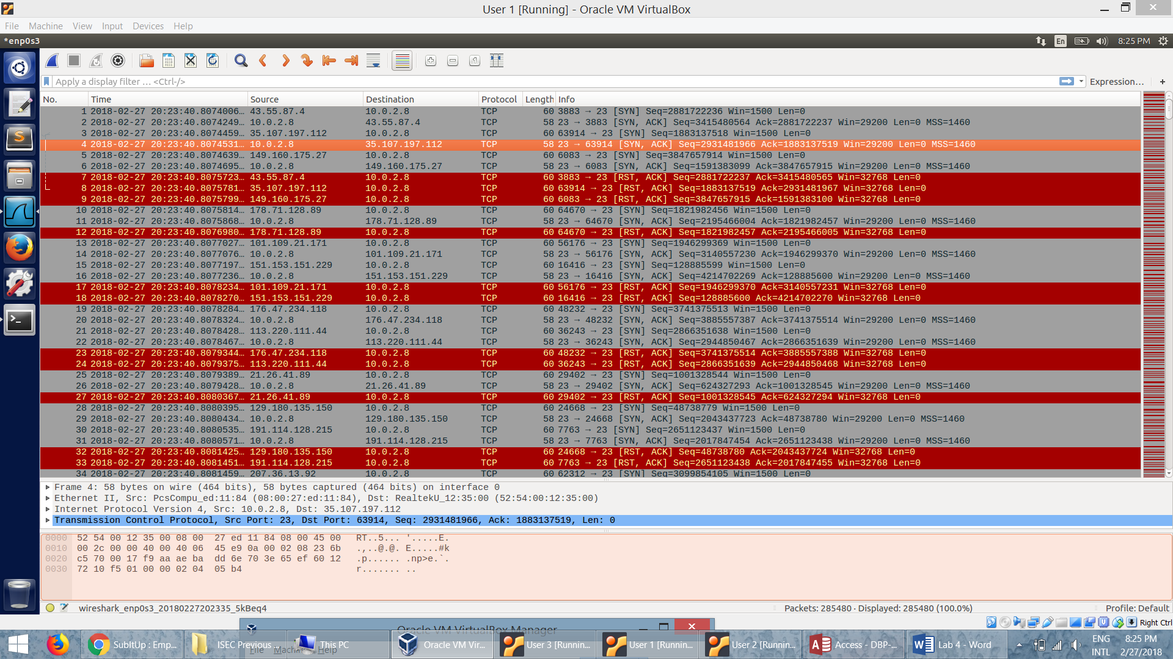

* SYN flooding is a form of DOS attack in which attackers send the victim with a lot of SYN packets with no intention to complete the 3 way handshake protocol. They target the half open connection TCP queue and plan to fill it up with requests so that the server freezes.
* The server is busy in utilizing all its resources in receiving, storing the SYN packets and *sending out ACK* for those packets.
* If the SYN packets come from 1 user then it is easy to block them, but the SYN packets come from various IPs. These IPs are not valid and they don’t complete the 3 way handshake. So server has to wait for the time out to reject these requests. When the packet is received, the status of the queue will be SYN_RECEIVED. When connection is established, it will be ESTABLISHED.
* Here the SYN cookie mechanism *is turned on,* so the queue is cleared when the queue is about to get full. Queue is not a necessity but only a performance improvement in the 3 way handshake. So this is the reason why the request for a new telnet connection goes through though the SYN flooding attack is in progress.
* We then ***turn off*** the syn cookie mechanism at the server so that the SYN flooding attack is successful.

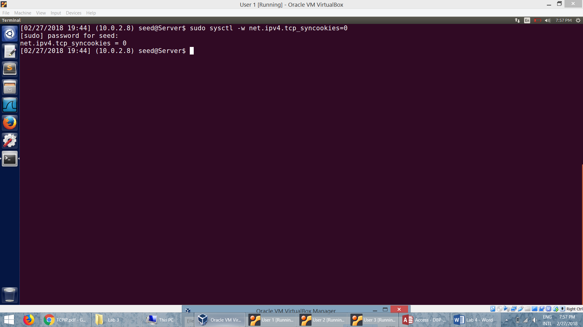

* We find that the telnet connection cannot be established from the observer because the queue is full in the server.

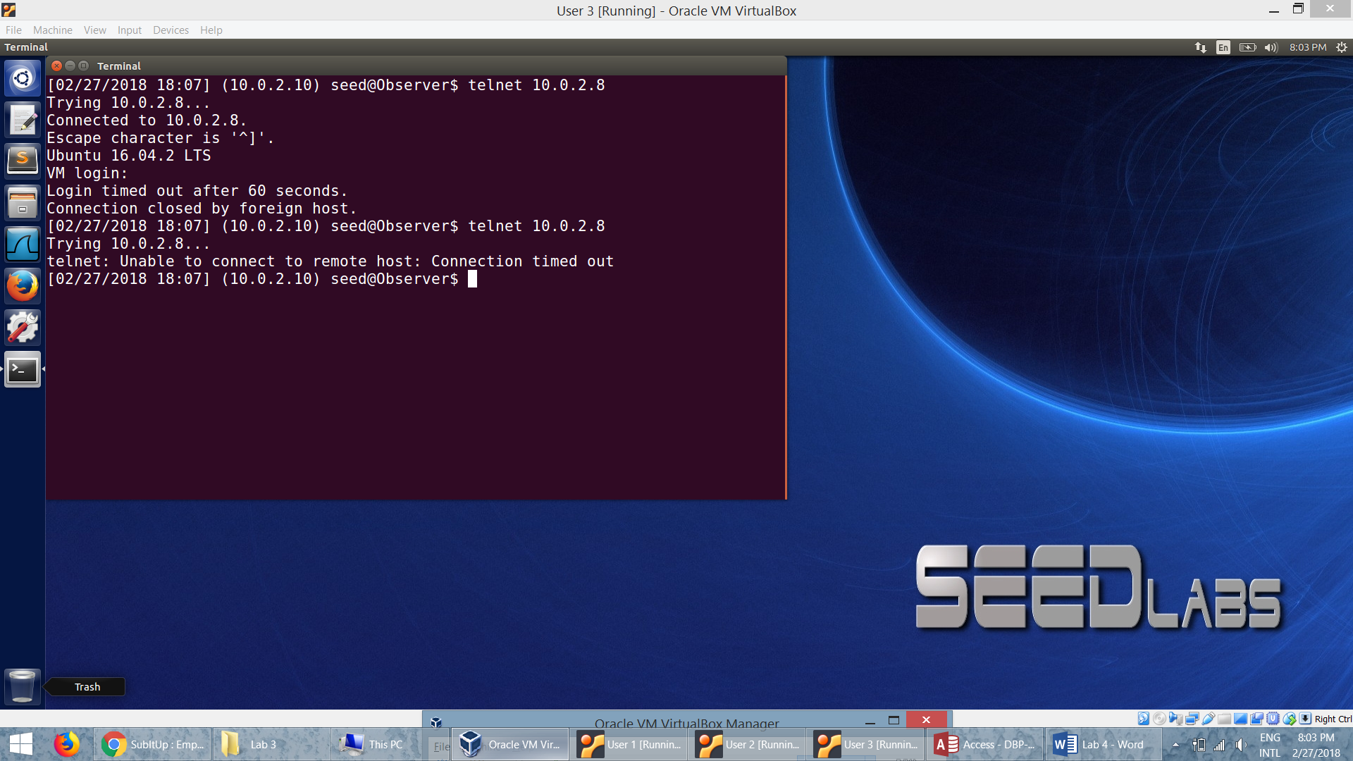

* The wireshark capture at the Server when we receive a lot of SYN packets:

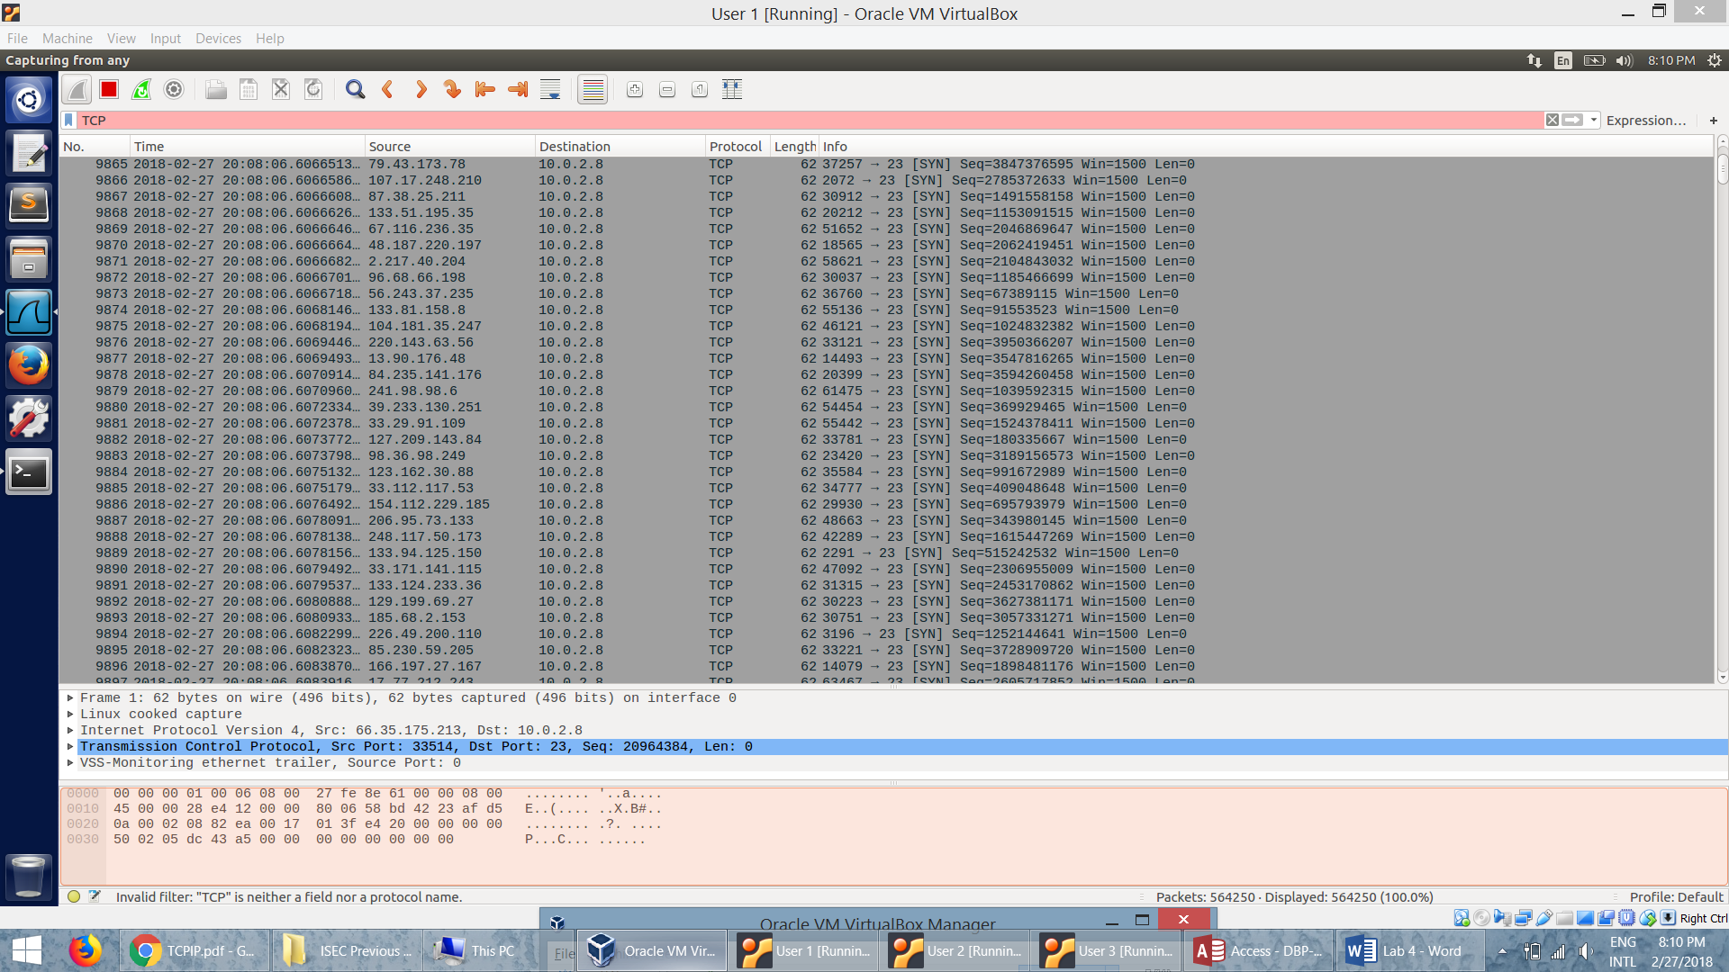

* The queue is full and the server allocates all its resources to these half open connections. So it cannot take in more incoming connections and has to drop the packets with new requests because the queue is full. Hence the telnet connection cannot go through when the SYN cookie mechanism is turned off.

**Task 2: TCP RST Attacks on telnet and ssh Connections:**

* First we establish a *telnet* connection to the server and obtain the next sequence number of the packet so that we can spoof the RST packet.

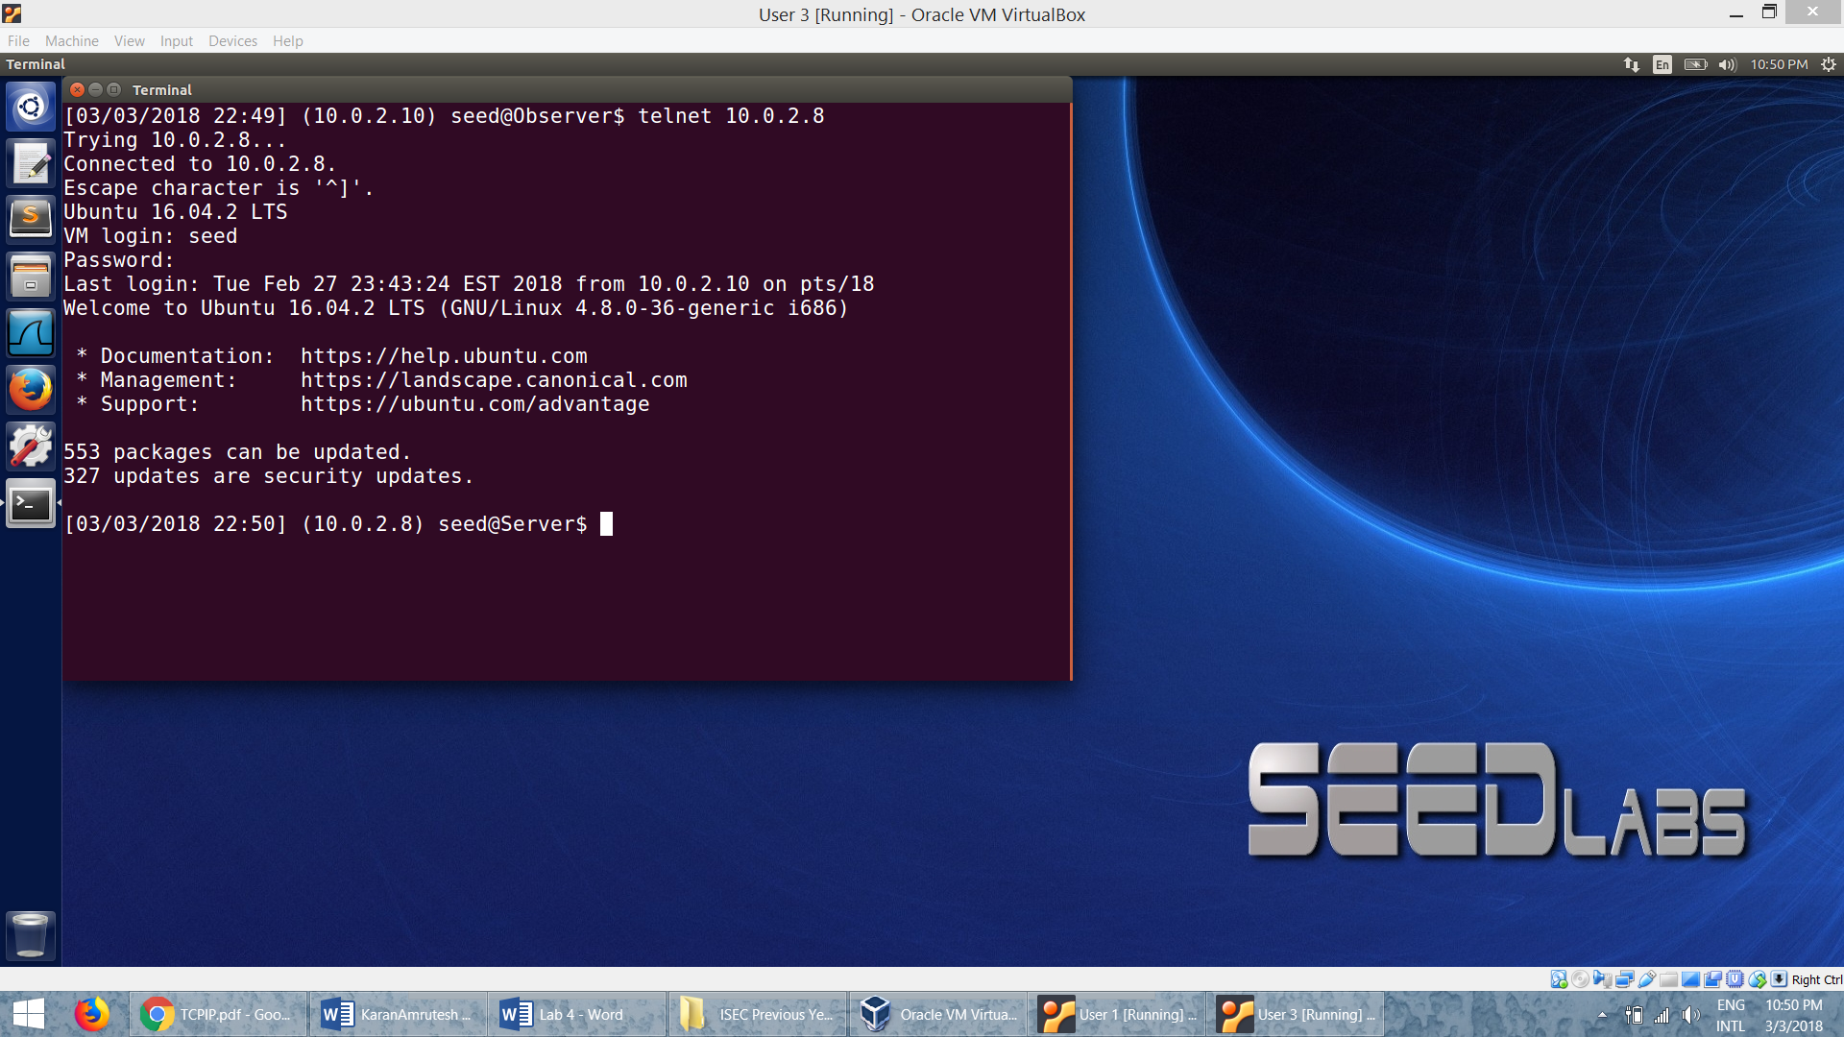

* We get the next sequence number from the Wireshark capture of the telnet connection from the Observer and Server

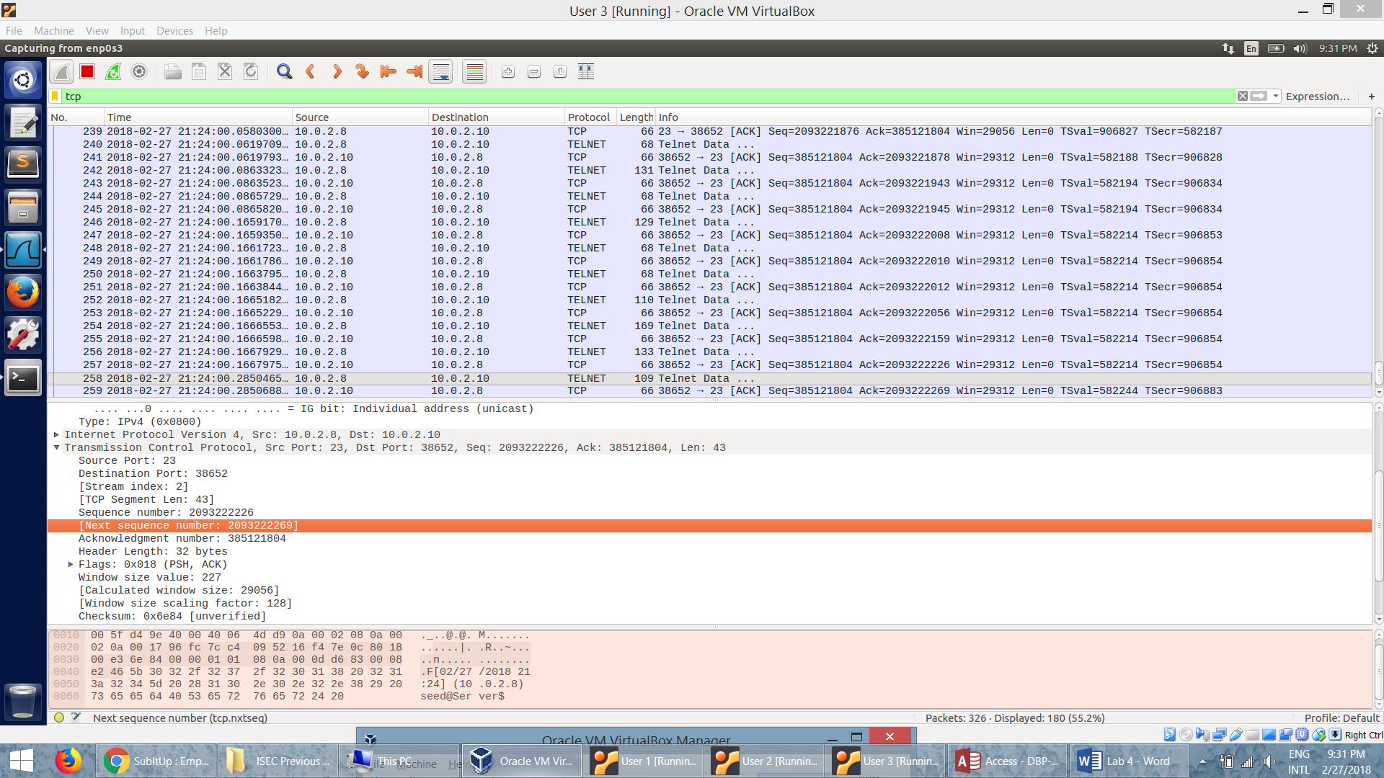

* **Attacker:** Then the attacker sends out TCP RST packets using the netwox tool with number 40. The attacker sends a spoofed RST packet as though its from the Server *(10.0.2.8)* to the Oberver *(10.0.8.10)* with the next sequence number obtained from the wireshark.

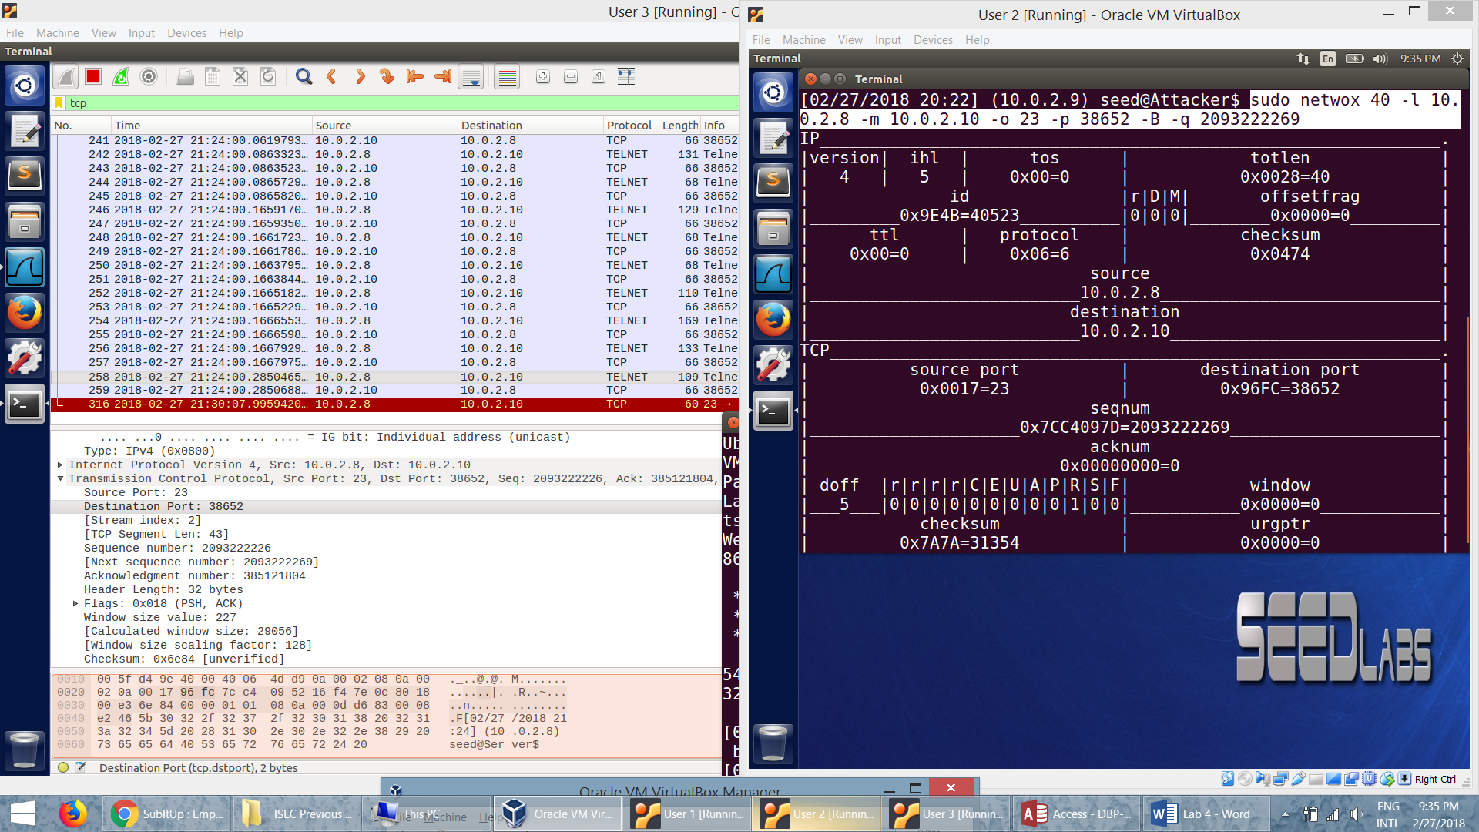

* At the **Observer,** we can see that the spoofed RST packet is received and the existing telnet connection is closed:

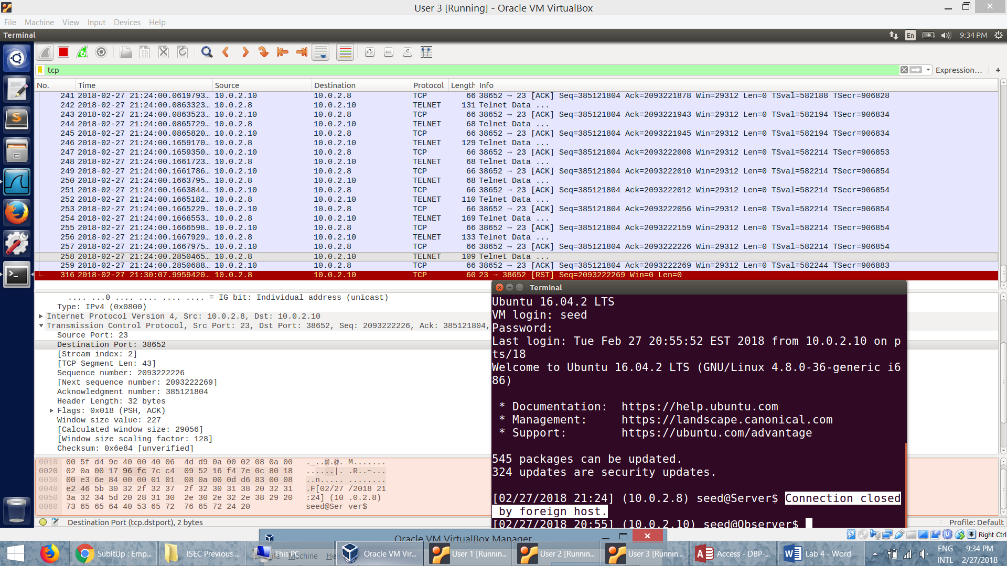

* Similarly we perform the TCP attack on the *SSH* connection:

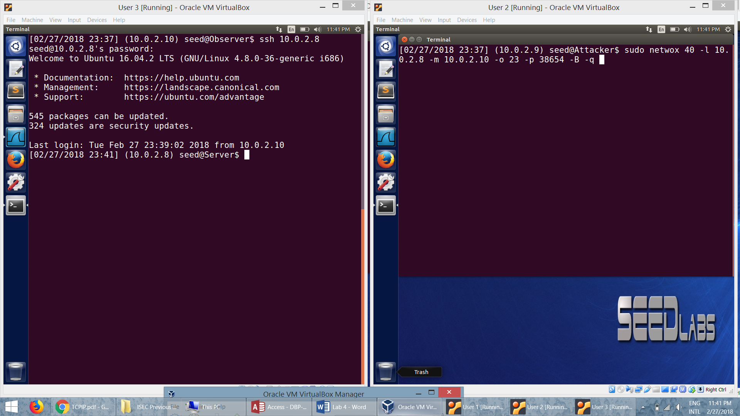

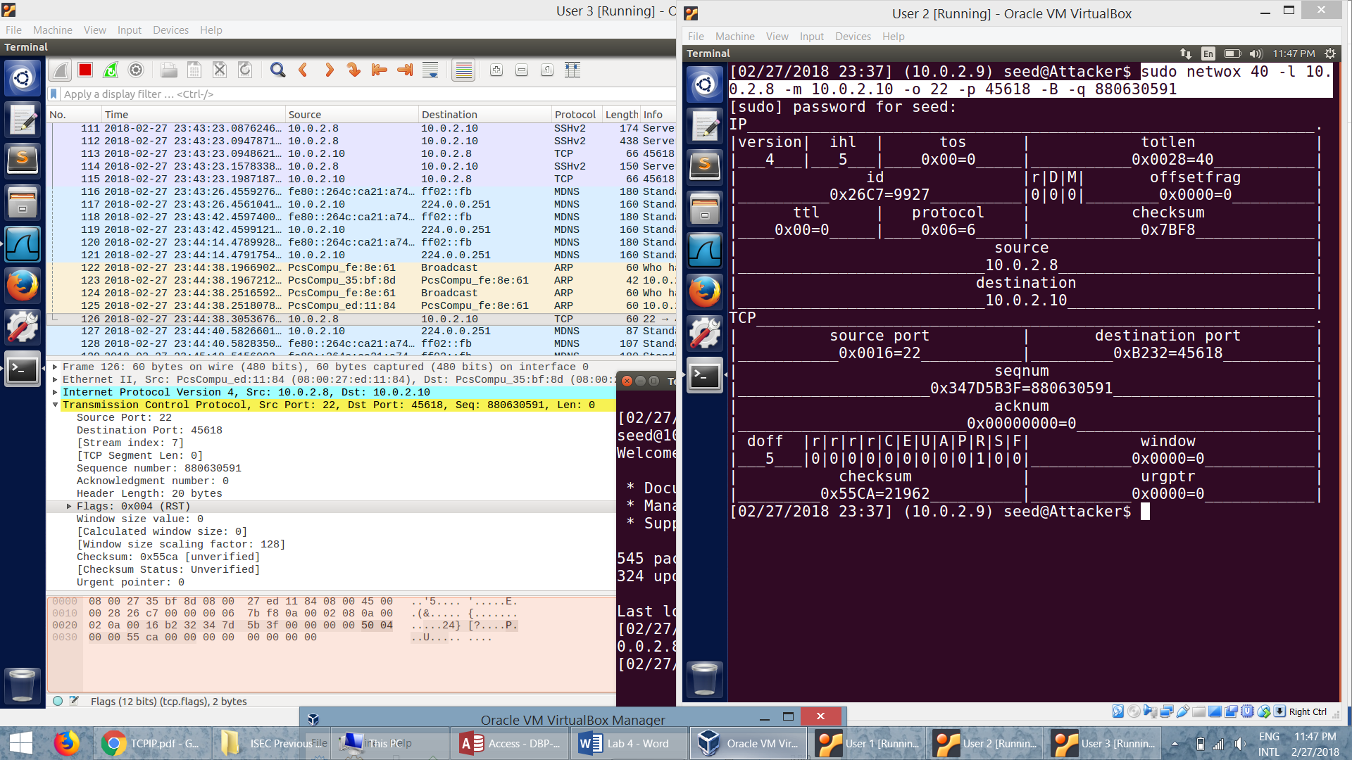

* SSH connection yields the same result. A RST packet breaks the connection between the server and the user.

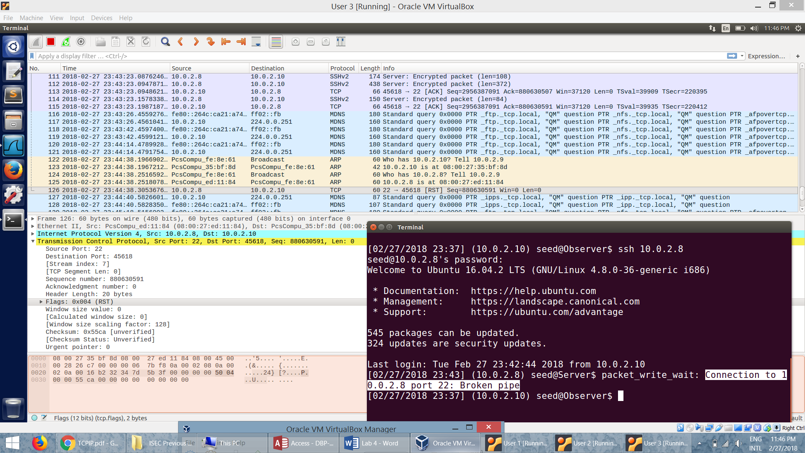

* TCP RST packet can terminate connection between the two parties any time without completing the acknowledgement. This is what attacker targets. He just sends out a RST packet to the user by posing as the server. So the user thinks that the server wants to terminate the connection and terminates the connection.

**Task 3 : TCP RST Attacks on Video Streaming Applications:**

* The video streaming site before the attack:

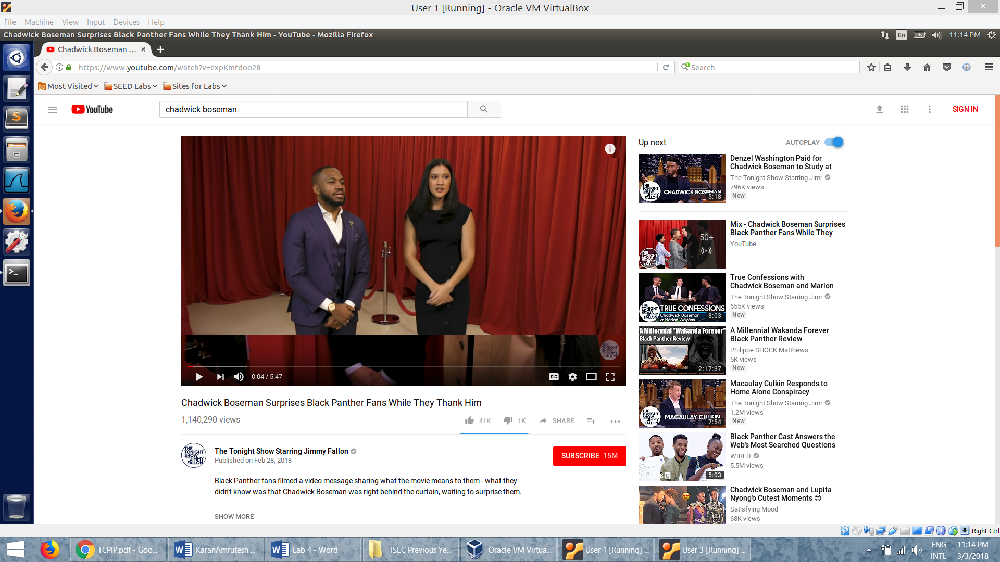

* The attacker user netwox tool with 78 to perform to attack and send out RST packets to the user streaming the site.

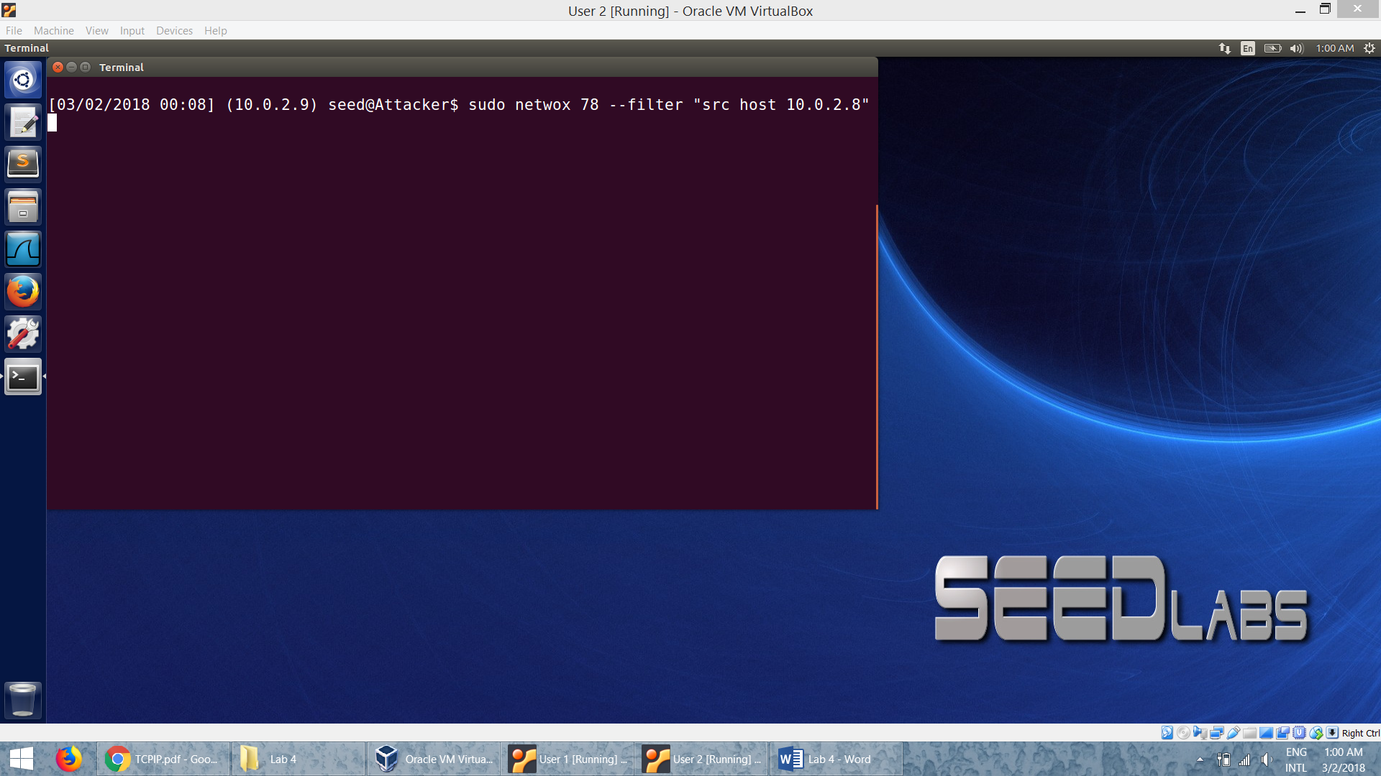

* The video streaming link is broken because the RST packet is sent by the attacker. The video does not load after the buffered part:

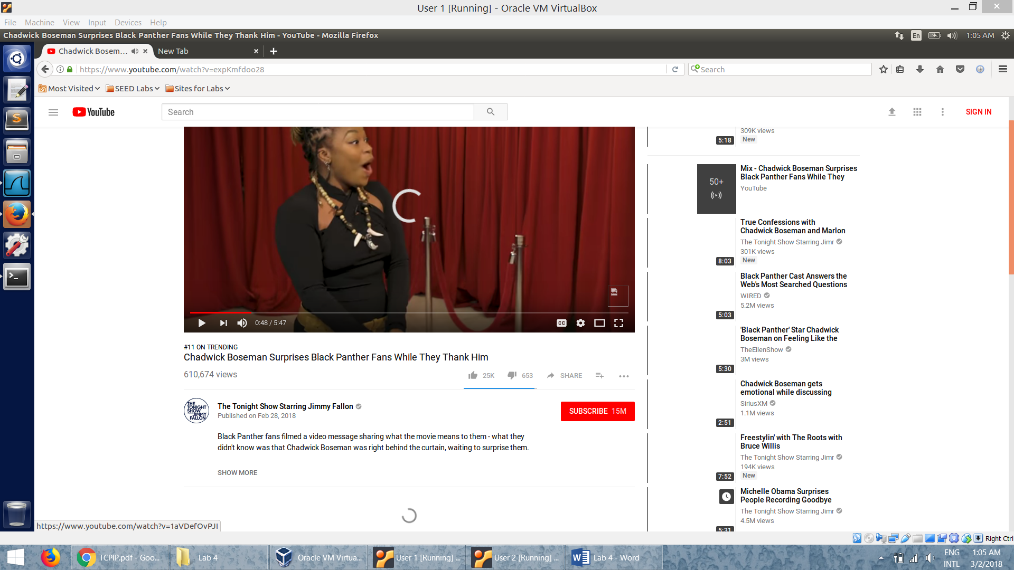

* The wireshark capture shows the attack is successful.

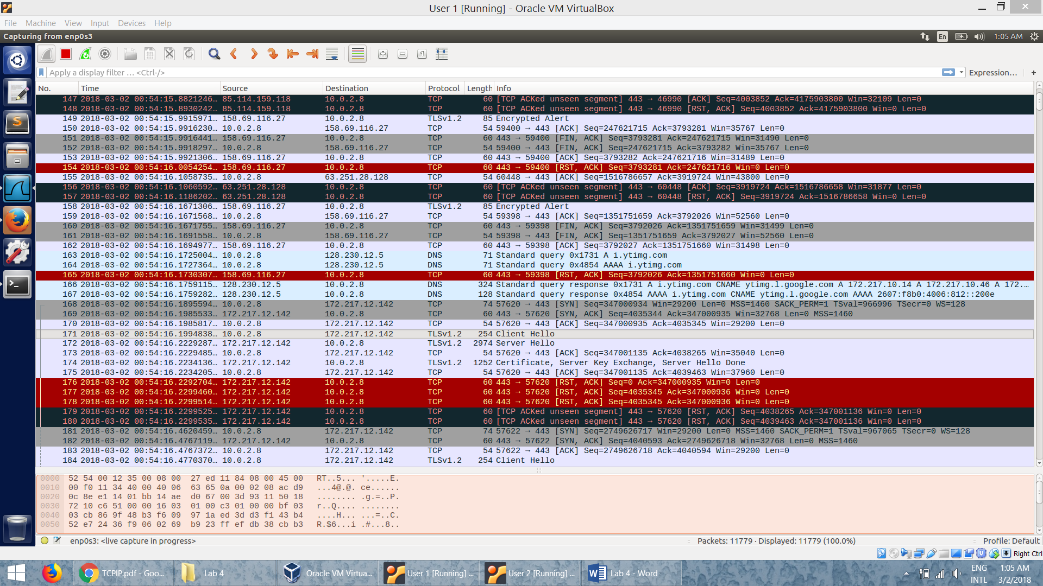

* TCP RST packet can terminate connection between the two parties any time without completing the acknowledgement. This is what attacker targets. He just sends out a RST packet to the user by posing as the server. So the user thinks that the server wants to terminate the connection and terminates the connection.

**Task 4: TCP Session Hijacking**

* A telnet connection is established between the user and the server. The Wireshark capture shown is the evidence of it.

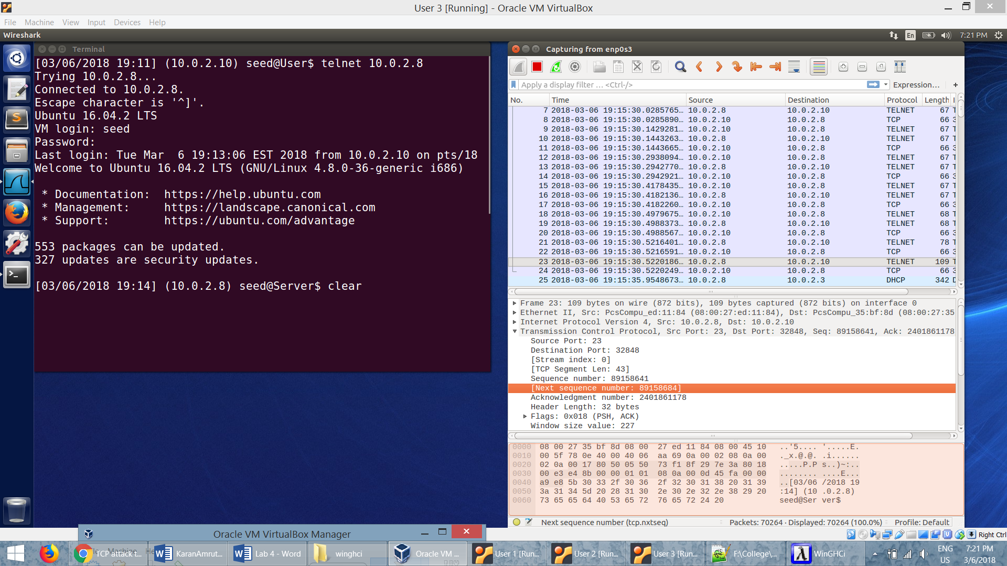

* From the Wireshark capture, we note down the next Sequence Number from user to server – 498442992, ACK Number – 3050751657.

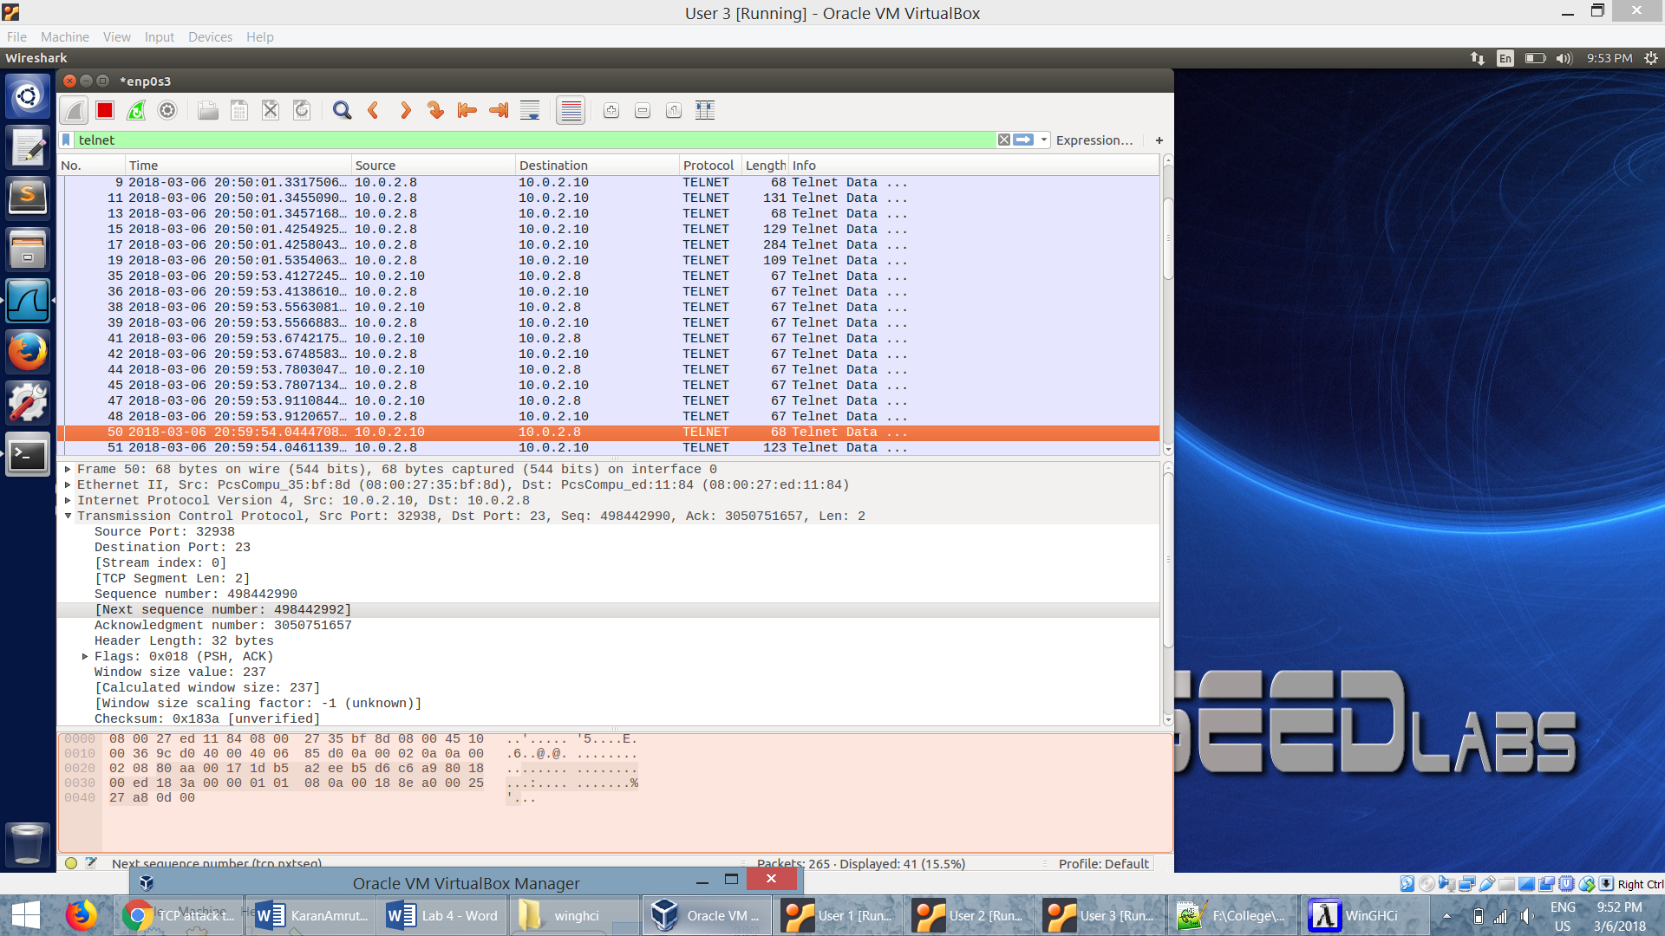

* We use the netcat (*nc*) command on the attacker to wait for a connection from the server. We run the *nc* command to set up TCP server listening on port 9090
* The *cat* command prints out the content of the *secret.txt* file. But instead of printing out locally, we redirect the output to a pseudo file /dev/tcp/10.0.2.9/9090, which creates a connection with the TCP server running on the attacker and send the data via the connection.

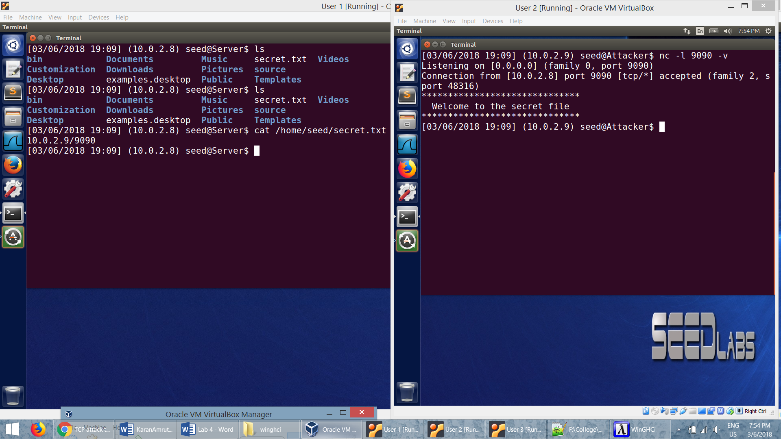

* We run a command in python to get the hex value which is used to launch the attack.

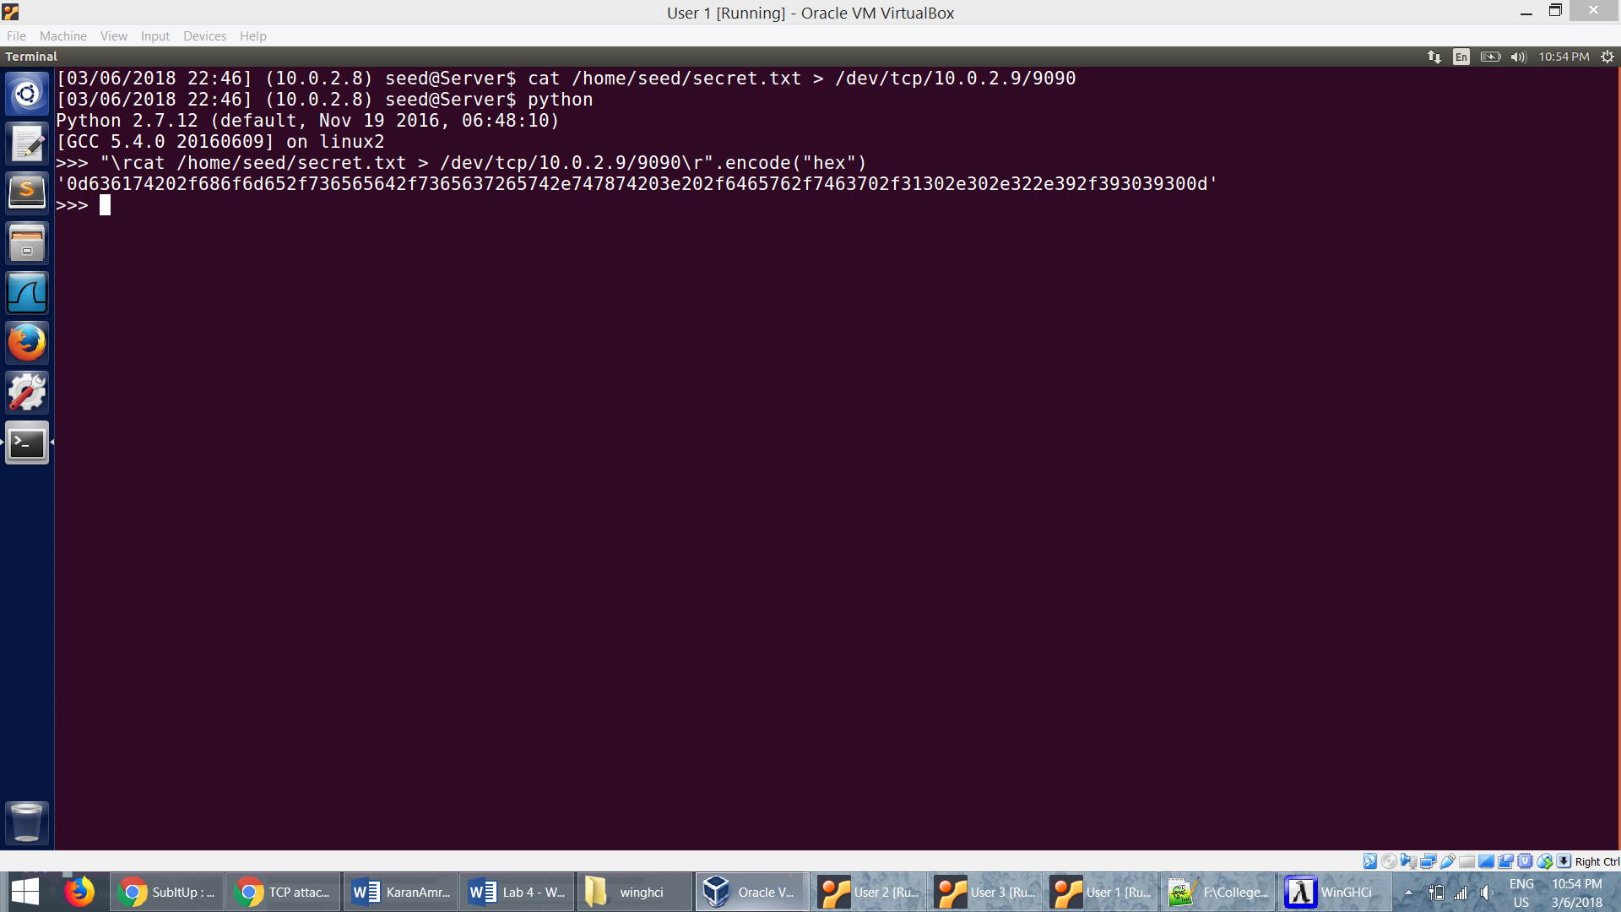

* The attacker uses the netwox 40 to spoof a TCP packet and hijack the session. We specify the source ip, destination ip, source port, destination port, sequence number, acknowledgment number and the data to be sent.

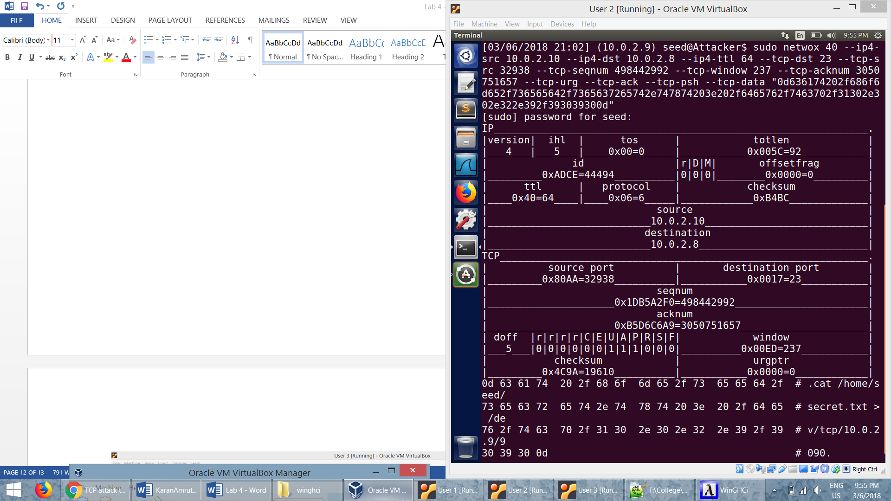

* After a successful attack, we can see that the terminal in the User freezes.
* In the Wireshark capture, we see that there are many retransmission packets between the use and the server.
* This is because the injected data by the attacker messes up the sequence number from the User to Server.

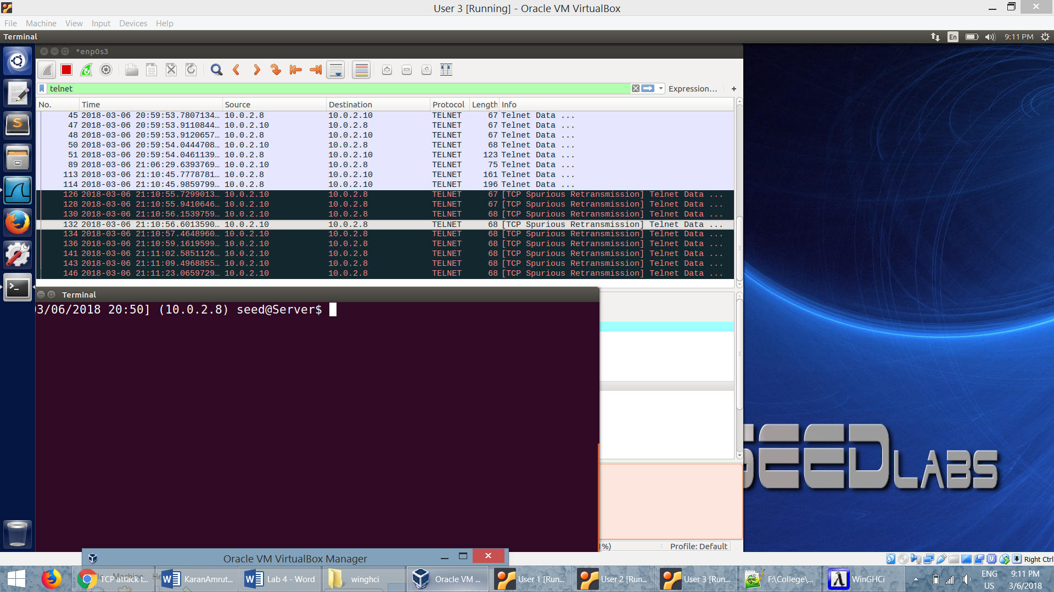

**Task 5: Creating Reverse Shell using TCP Session Hijacking**

* A telnet connection is established between the user and the server. The Wireshark capture shown is the evidence of it.

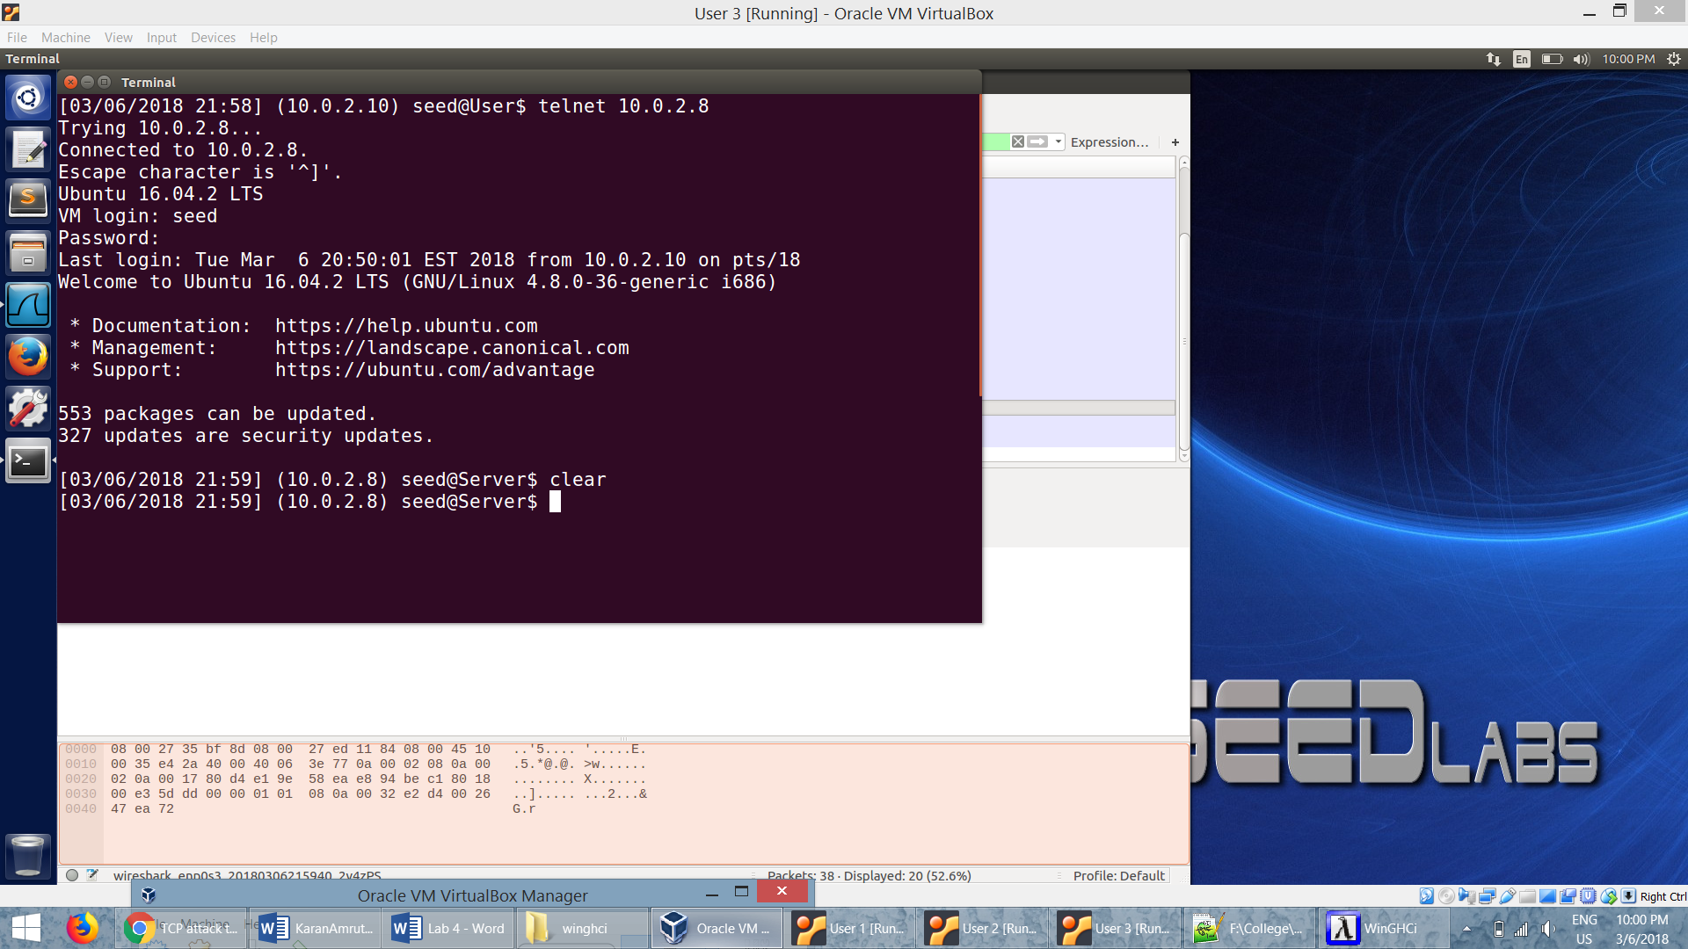

* From the Wireshark capture, we note down the various packet information.

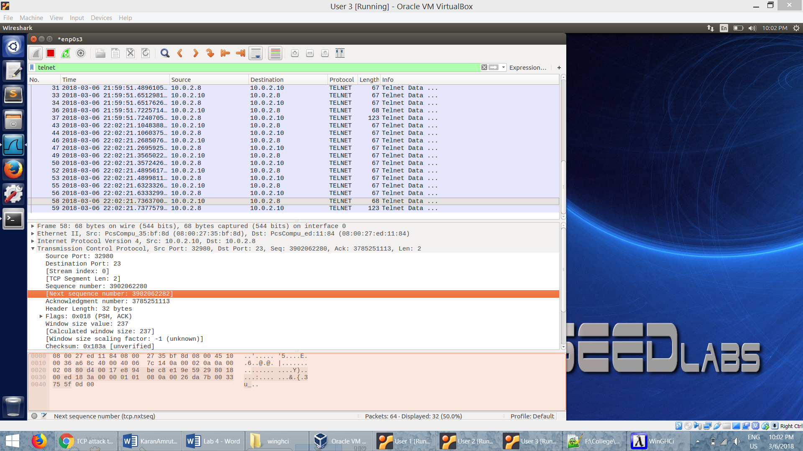

* To launch the attack we need to get the hex value. For this purpose we use python.
* We need to get the shell program to use the TCP pseudo device for its input. We can achieve that by appending 0<&1.
* By specifying 2>&1, we are redirecting the standard error device (file descriptor 2) to the file descriptor 1, basically forcing the program to also use the std output device for printing out error messages.

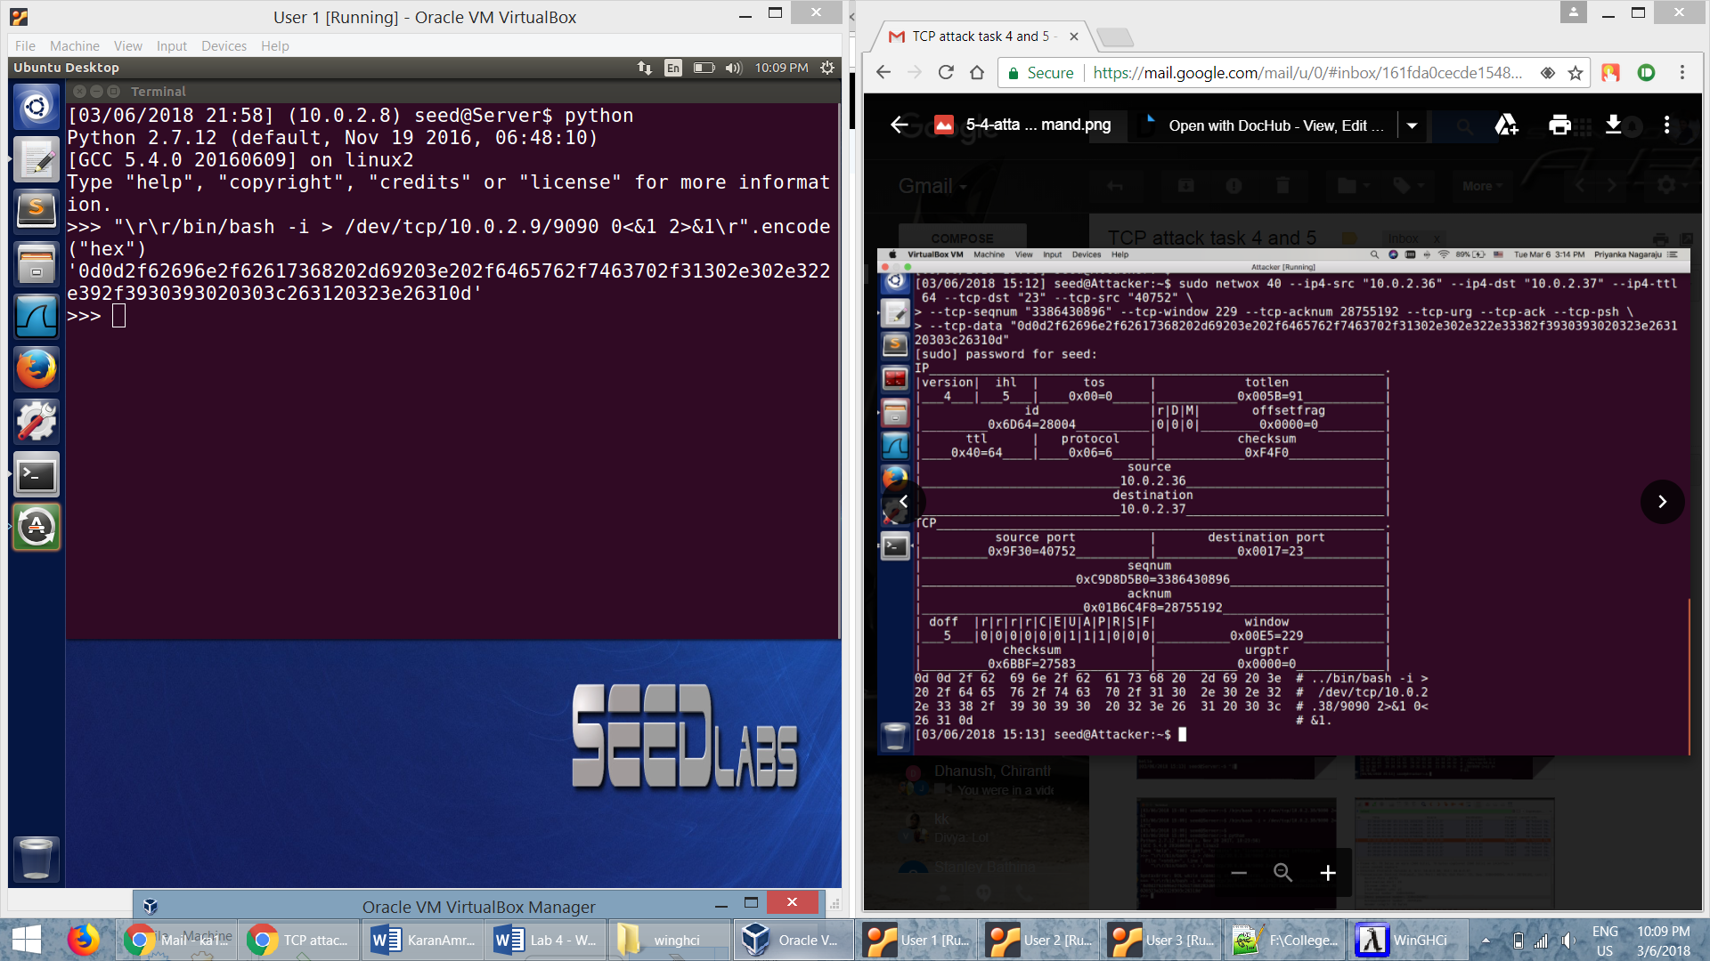

* The attacker uses the netwox 40 to spoof a TCP packet and hijack the session. We specify the source ip, destination ip, source port, destination port, sequence number, acknowledgment number and the data to be sent.

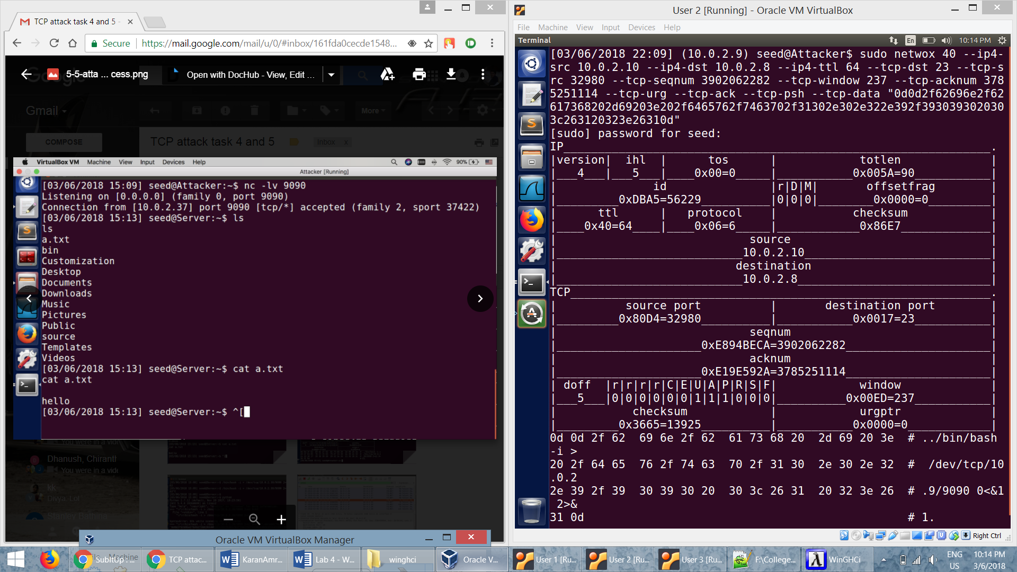

* When the attack is successful we get the reverse shell on the attacker machine.
* The *nc* command will send whatever we type on the Attacker to remote shell program on the server and relay back whatever is printed out by the remote shell program. Hence we will have the full control of the remote shell program.

